**VIETNAM NATIONAL UNIVERSITY HO CHI MINH CITY**

**HO CHI MINH CITY UNIVERSITY OF TECHNOLOGY**

**FACULTY OF TRANSPORTATION ENGINEERING**

**DEPARTMENT OF AUTOMOTIVE AND ENGINE**

GRADUATION THESIS

**STUDY ON AUTOMOTIVE PUSH-ROD SUSPENSION**

**SYSTEM**

|  |  |
| --- | --- |
| Student name:  Student ID:  Instructor: | Nhu Quoc Huy  1852412  Ph.D Tran Dang Long |

Ho Chi Minh city, 2022 

|  |  |
| --- | --- |
| **HCMC UNIVERSITY OF TECHNOLOGY**  Faculty of Transportation Engineering | SOCIAL REPUBLIC OF VIETNAM  Independence - Freedom - Happiness |

**------------------------------------**

**THESIS ASSIGNMENT**

**Student’s full name:** NHU QUOC HUY ................................... **Student’s ID:** 1852412

**Training program:** Automotive Engineering

|  |  |
| --- | --- |
| **Class:**CC18OTO1 |  |

**1. Thesis title:** STUDY ON AUTOMOTIVE PUSH-ROD SUSPENSION SYSTEM

**2. Requested content:**

- Build 3D model of the Push-rod suspension system by SolidWorks.   
- Import the 3D model to the Matlab/Multibody environment to build the dynamic model

of the Push-rod suspension system.

- Simulate the Road profile by exciting the harmonic profile to the suspension system.   
- Using the m file to run the simulation model.   
- Determine the change in camber angle when the suspension is oscillating.

**3. Requested products:**

✓ Full report

✓ Poster

**4. Date of assignment** *(dd/mm/yyyy)***: 01/01/2022** ................

**5. Date of accomplishment** *(dd/mm/yyyy)***: 10/06/2022** ........

**The Thesis assignment is approved by the Department of Automotive Engineering.**

|  |  |
| --- | --- |
| *Date (dd/mm/yyyy):* ………………….  **Head of Department** | *Date (dd/mm/yyyy):* ………………….  **Thesis Advisor** |

STUDY ON AUTOMOTIVE PUSH-ROD SUSPENSION SYSTEM

**ACKNOWLEDGEMENT**

First and foremost, I want to express my gratitude to my family, who have always been by my side, accompanying, supporting, and assisting me in any way possible so that I can get to where I am now.

I want to thank the teachers at Bach Khoa University in general and the Department of Automotive Engineering in particular for their efforts. The knowledge I have gained from teachers over the last four years has assisted me in being brave enough to complete this thesis.

Sincere thanks to PhD. Tran Dang Long, Mr. Thanh Long – Bosch Engineer, Mr. Hoang Tien – Bosch Engineer and the team of Bosch Automotive R&D Center in Vietnam created conditions for me to study, practice and conduct field surveys.

Finally, I want to thank the reviewer and department lecturers for sharing their knowledge and providing me with feedback and suggestions so that I could finish this thesis.

Wishing health to parents, family, lecturers in the Faculty of Transportation Engineering as well as lecturers in the Department of Automotive Engineering and all of my friends in class CC18OTO1.

|  |  |  |
| --- | --- | --- |
| Instructor: Ph.D Tran Dang Long |  | I |

STUDY ON AUTOMOTIVE PUSH-ROD SUSPENSION SYSTEM

**ABSTRACT**

The aim of this study is to study on automotive Push-rod suspension system by

evaluating the technical characteristics of the Push-rod suspension system include: Spring

stiffness, damping coefficient, natural frequency and the change in wheel alignment but

this study will not evaluate the frequency-weighted acceleration to calculate how intensive

vibrations affect human body, beside that this study will also evaluate the relationship

between wheel displacement and the suspension travel. To determine the characteristics of

the Push-rod suspension system, in this study we compare the Push-rod suspension system

to the conventional suspension system (SYM T880) with the same excited road profile and

natural frequency as well as damping ratio to evaluate the spring stiffness, damping

coefficient and the change in wheel alignment which is specified by camber angle through

simulation by using SolidWorks and Matlab/ Multibody environment. In this study,

SolidWorks is used to build 3D models of the Push-rod and conventional suspension

system, the translational base and fix base to simulate the road profile such as harmonic

road profile and step road profile. Matlab/ Multibody environment is used to build a

dynamic model and simulate the excited road profile to the system, also evaluate the change

in wheel alignment, which is the change in camber angle when the suspension is oscillating

with different types of road profile excited on it. Create m file in Matlab to transfer the

oscillation follows the time domain to the oscillation follows the frequency domain in order

to evaluate the frequency response through the natural frequency of the system.

|  |  |  |
| --- | --- | --- |
| Instructor: Ph.D Tran Dang Long |  | II |

STUDY ON AUTOMOTIVE PUSH-ROD SUSPENSION SYSTEM

**Table of Contents**   
**CHAPTER 1: TOPIC OUTLINE .................................................................................... 1**

|  |  |  |
| --- | --- | --- |
| **1.1** | **Introduction:......................................................................................................... 1** | |
| **1.2** | **Domestic and foreign research situation: .......................................................... 1** | |
| **1.3** | **Thesis scope and objectives: ................................................................................ 2** | |
| **1.4** | **Research methodology: ....................................................................................... 2** | |
| **1.5** | **Thesis content: ...................................................................................................... 2** | |
| **1.6** | **Scientific and practical significance: .................................................................. 3** | |
| **1.6.1** | | **Scientific significance: ................................................................................... 3** |
| **1.6.2** | | **Practical significance: ................................................................................... 3** |

**CHAPTER 2: SUSPENSION SYSTEM OUTLINE ...................................................... 4**

|  |  |
| --- | --- |
| **2.1**  **2.2** | **Introduction:......................................................................................................... 4**  **Suspension system components: ......................................................................... 5** |

**CHAPTER 3: THEORETICAL BASIS .......................................................................... 8**

|  |  |  |
| --- | --- | --- |
| **3.1** | **Spring stiffness and damping coefficient: .......................................................... 8** | |
| **3.2** | **Natural frequency and damping ratio: .............................................................. 9** | |
| **3.2.1** | | **Natural frequency: ...................................................................................... 10** |
| **3.2.2** | | **Damping ratio:............................................................................................. 10** |
| **3.3** | **Wheel alignment: ............................................................................................... 12** | |
| **3.4** | **Types of road excitation: ................................................................................... 15** | |

**CHAPTER 4: MODEL DESCRIPTION ...................................................................... 18**

|  |  |  |  |
| --- | --- | --- | --- |
| **4.1** | **Method and solutions: ....................................................................................... 18** | | |
| **4.2** | **Build 3D model on SolidWorks: ....................................................................... 18** | | |
| **4.3** | **Build dynamic model: ........................................................................................ 20** | | |
| Instructor: Ph.D Tran Dang Long | |  | III |

STUDY ON AUTOMOTIVE PUSH-ROD SUSPENSION SYSTEM

|  |  |
| --- | --- |
| **4.4**  **4.5**  **4.6** | **Road profile simulation: .................................................................................... 21**  **Calculation flow: ................................................................................................ 22**  **Conclusion of chapter 4: .................................................................................... 23** |

**CHAPTER 5: RESULT AND DISCUSSION ............................................................... 24**

|  |  |
| --- | --- |
| **5.1**  **5.2**  **5.3**  **5.4** | **Relationship between wheel displacement and suspension travel: ............... 24**  **Change in camber angle and sliding range of tire: ......................................... 25**  **Gain response spectrum: ................................................................................... 25**  **Conclusion of chapter 5: .................................................................................... 30** |

**CHAPTER 6: CONCLUSIONS AND FUTURE WORKS ......................................... 31**

|  |  |
| --- | --- |
| **6.1**  **6.2** | **Thesis conclusion: .............................................................................................. 31**  **Future works: ..................................................................................................... 31** |

**APPENDIX ....................................................................................................................... 33**

**REFERENCES ................................................................................................................ 39**

|  |  |  |
| --- | --- | --- |
| Instructor: Ph.D Tran Dang Long |  | IV |

STUDY ON AUTOMOTIVE PUSH-ROD SUSPENSION SYSTEM

**List of Figures**

**Figure 1. Push-rod suspension system5 ............................................................................ 4**

**Figure 2. Types of spring .................................................................................................. 6**

**Figure 3. Characteristics curve of elastic element .......................................................... 6**

**Figure 4. Twin-tube (a) and mono-tube (b) dampers1 ................................................... 7**

**Figure 5. Characteristics curve of damping element ..................................................... 7**

**Figure 6. Coil spring parameters ..................................................................................... 8**

**Figure 7 Practical characteristic curve of damping element ......................................... 9**

**Figure 8. Underdamped characteristics curve ................................................................ 9**

**Figure 9. Sample time response for underdamped system1 ......................................... 11**

**Figure 10. Sample time response for critically-damped system1 ................................ 11**

**Figure 11. Sample time response for over-damped syste1 ........................................... 12**

**Figure 12. Positive and Negative camber angle6 ........................................................... 13**

**Figure 13. Positive and negative caster angle9 .............................................................. 14**

**Figure 14. Toe in and toe out of the wheel9 ................................................................... 15**

**Figure 15. The harmonic road profile1 .......................................................................... 16**

**Figure 16. The transient road profile1 ........................................................................... 16**

**Figure 17. The random road profile .............................................................................. 17**

**Figure 18. 3D models of Push-rod suspension system and Conventional suspension**

**system ................................................................................................................................ 19**

**Figure 19. Simulation model in Matlab/Multibody environment ............................... 20**

**Figure 20. Simulation input and output parameters .................................................... 21**

**Figure 21. Harmonic road profile simulation on Matlab/ Multibody ........................ 21**

**Figure 22. Calculation flowchart of the simulation models ......................................... 22**

**Figure 23. Relationship between wheel displacement and suspension travel curve . 24**

**Figure 24. Relationship between change in camber angle and tire's sliding range**

**curve .................................................................................................................................. 25**

**Figure 25. Gain response spectrum of 1/3 load condition ............................................ 26**

**Figure 26. Gain response spectrum of 2/3 load condition ............................................ 27**

|  |  |  |
| --- | --- | --- |
| Instructor: Ph.D Tran Dang Long |  | V |

STUDY ON AUTOMOTIVE PUSH-ROD SUSPENSION SYSTEM

**Figure 27. Gain response spectrum of full load condition ........................................... 28**

|  |  |  |
| --- | --- | --- |
| Instructor: Ph.D Tran Dang Long |  | VI |

STUDY ON AUTOMOTIVE PUSH-ROD SUSPENSION SYSTEM

**List of Tables**

**Table 1. SYM T880 suspension parameters (Source: Vibration analysis of a light**

**truck by 3d dynamic vehicle vibration model by Mr. Truong Hoang Tuan, Dr. Tran**

**Huu Nhan and Mr. Tran Quang Lam.)3 ....................................................................... 19**

**Table 2. Natural frequency and damping ratio of Push-rod and Conventional**

**suspension system with different load conditions ......................................................... 29**

**Table 3. Spring stiffness and damping coefficient of Push-rod and Conventional**

**suspension system ............................................................................................................ 29**

|  |  |  |
| --- | --- | --- |
| Instructor: Ph.D Tran Dang Long |  | VII |

STUDY ON AUTOMOTIVE PUSH-ROD SUSPENSION SYSTEM

**CHAPTER 1: TOPIC OUTLINE**

**1.1 Introduction:**

The vehicle’s suspension system is used to connect the wheels to the vehicle body and

allow relative motions. With different types of suspension systems, the suspension systems

will have different technical characteristics with the same working conditions such as same

road excitation, same natural frequency…Therefore, it is necessary to determine the

technical characteristics of a variety of suspension systems to choose the optimal design of

the suspension system. For that reason, researchers studying the automotive Push-rod

suspension system, one of the most popular suspension system for F1 racing cars or high

performance cars.

In Vietnam, the economy in general and the automotive industry in specific is becoming

more and more developed in computer-based systems, transport networks and hence,

improving people’s safety and driveability. Consumers are going along the trend of

purchasing and using high quality products for customizing and modifying their vehicles.

Suspension system is not an exception.

To get the appropriate parameters for a suspension of a specific vehicle, many

researchers are required. The combination of mathematical model and computational tools

is very useful in analysing the technical characteristics of the Push-rod suspension system.

**1.2 Domestic and foreign research situation:**

In Vietnam, more and more researchers are paying much attention to the technical

characteristics of the suspension system but only a few researches about the Push-rod

suspension system.

In the World, many scientific papers are also being published about the Push-rod

suspension system, focusing on evaluating the technical characteristics. A group of

researchers Samant Saurabh Y., Santosh Kumar, Kaushal Kamal Jain, Sudhanshu Kumar

Behera, Dhiraj Gandhi, Sivapuram Raghavendra, Karuna Kalita had released the paper

“Design of Suspension System for Formula Student Race Car”. In this paper, the group of

|  |  |  |
| --- | --- | --- |
| Intructor: Ph.D Tran Dang Long |  | 1 |

STUDY ON AUTOMOTIVE PUSH-ROD SUSPENSION SYSTEM

authors had found the technical characteristics of the Push-rod suspension system in the

Formula student race car.

**1.3 Thesis scope and objectives:**

The scope of this thesis is to derive the technical characteristics of the Push-rod

suspension system of a semi-car, solve the simulation model by Matlab/ Multibody

environment base on the parameters of the Conventional suspension system (SYM T880),

not evaluate the vibrations affect human body.

The objectives of this thesis is to evaluate the technical characteristic of the Push-rod

suspension system includes:

- The relationship between the wheel displacement and the suspension travel

- The spring stiffness and the damping coefficient with the same natural frequency and

damping ratio of the Conventional suspension system

- The change in camber angle and the sliding range of tire slip.

The hypothesis of this thesis is that the simulation will neglect the tire’s stiffness and

sliding friction between road and tire, use the vehicle’s mass of SYM T880

**1.4 Research methodology:**

The research method for this thesis is theoretical research. Combine with results from

relevant scientific research and books.

**1.5 Thesis content:**

This thesis consists of 6 chapters as follows:

- Chapter 1: Topic outline

- Chapter 2: Suspension system outline

- Chapter 3: Theoretical basis

- Chapter 4: Model descriptions

- Chapter 5: Results and discussion

- Chapter 6: Conclusions and future works

|  |  |  |
| --- | --- | --- |
| Intructor: Ph.D Tran Dang Long |  | 2 |

STUDY ON AUTOMOTIVE PUSH-ROD SUSPENSION SYSTEM

**1.6 Scientific and practical significance:**

**1.6.1 Scientific significance:**

Understanding the technical characteristics of the Push-rod suspension system includes:

spring stiffness of elastic element, damping coefficient of damping element and the natural

frequency as well as damping ratio.

**1.6.2 Practical significance:**

The study of the suspension characteristics (spring stiffness, damping coefficient) and

the relationship between different displacement (suspension travel, wheel displacement,

camber angle, tire sliding range)

|  |  |  |
| --- | --- | --- |
| Intructor: Ph.D Tran Dang Long |  | 3 |

STUDY ON AUTOMOTIVE PUSH-ROD SUSPENSION SYSTEM

**CHAPTER 2: SUSPENSION SYSTEM OUTLINE**

**2.1 Introduction:**

Suspension system is the one that connects the wheels to the vehicle body and allows

relative motions, it also supports the weight of the vehicle body.

The primary functions of suspensions are:

- Isolating roughness between the road and the vehicle chassis.

- Support the weight of the vehicle body.

- React to the control forces generated by the tires during operating such as

longitudinal forces, braking and driving torque.

- Keep the tires in contact with the road surface.

- Dissipate the energy from the road applied on the tires.

- Resist the roll of chassis, allow rapid cornering without extreme body roll.

The push-rod suspension system has the same function of the conventional suspension

system but it has the difference in structural linkage.

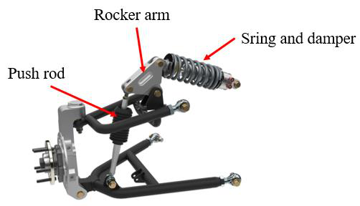

*Figure 1. Push-rod suspension system5*

|  |  |  |
| --- | --- | --- |
| Intructor: Ph.D Tran Dang Long |  | 4 |

STUDY ON AUTOMOTIVE PUSH-ROD SUSPENSION SYSTEM

The difference between Push-rod suspension system and conventional suspension

system is that the Push-rod suspension includes the rocker arm, push-rod and the

suspension will be allocated horizontally.

**2.2 Suspension system components:**

- Guiding elements:

o Control arms, links.

o Push rod.

o Rocker arm.

- Force elements:

o Coil spring, air spring.

o Damper.

o Bushing, hydro-mounts.

- Tires.

The tires are a kind of air spring that supports the weight of the vehicle since the inside

of the tire is filled with air. The spring action of the tire is very important to the ride quality

and safe handling of the vehicle. In addition, the tire must provide the forces and torque

that keep the vehicle on track.

The force elements of suspension system are divided into the following elements:

- Inertia elements

- Elastic elements

- Damping elements

The mechanical element that stores kinetic energy is called *‘mass’*, and the

mechanical element that stores potential energy, is called ‘*spring’*. If the total value of

mechanical energy 𝐸 = 𝐾 + 𝑉decreases during a vibration over time, then there is a

mechanical element that dissipates the mechanical energy. That dissipative element is

called *‘damper’.*

|  |  |  |
| --- | --- | --- |
| Intructor: Ph.D Tran Dang Long |  | 5 |

STUDY ON AUTOMOTIVE PUSH-ROD SUSPENSION SYSTEM

Elastic elements help support the vehicle’s weight. In vehicle suspension systems,

coil springs, air springs, torsion bars and leaf springs are widely used; coil spring is

commonly used for Push-rod suspension systems. Elastic elements also store the potential

energy from the vibrations.

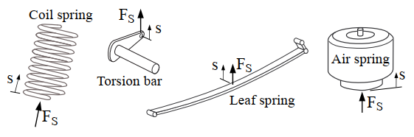

*Figure 2. Types of spring1*

The characteristic curve of the elastic element is given below. During operation, the

elastic element will generate an elastic force 𝐹𝑆, this force is proportional to the

displacement of the elastic element (known as the relative displacement). When the elastic

element is compressed, the relative displacement is a negative value, when it is elongated,

the relative displacement is a positive value.

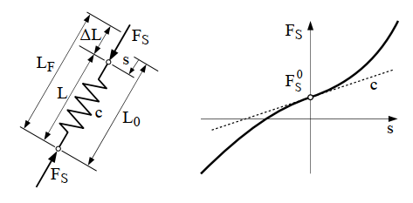

*Figure 3. Characteristics curve of elastic element1*

Damping elements are also called shock absorbers or dampers. They are basically

oil pumps, consist of a tube, piston and carry hydraulic oil inside the tube. As the

1 Georg Rill (2012), *Road Vehicle Dynamics: Fundamentals and Modeling*, CRC Press, p.166.

|  |  |  |
| --- | --- | --- |
| Intructor: Ph.D Tran Dang Long |  | 6 |

STUDY ON AUTOMOTIVE PUSH-ROD SUSPENSION SYSTEM

suspension travels up and down, the fluid is forced by the piston through small holes, called

orifices. This will generate a friction force and slow down the motion of the piston.

Nowadays, twin-tube and mono-tube are usually used in vehicle suspension systems.

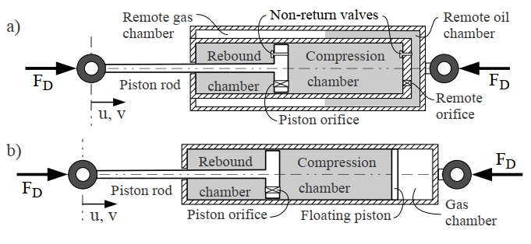

*Figure 4. Twin-tube (a) and mono-tube (b) dampers1*

The characteristic curve of the damping element is given below. When the piston

travels up and down the damper, the movement of the fluid through orifices produces a

friction force 𝐹𝐷, this force is proportional to the speed of the movement of the piston.

When the piston travels down in the tube, it is in the compression state, when the piston

travels upward, it is in the rebound state.

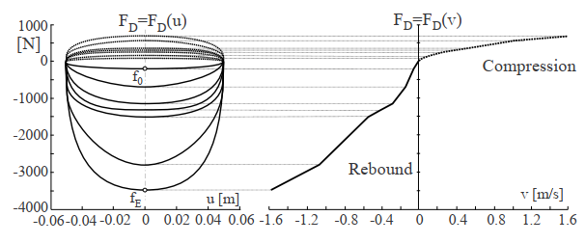

*Figure 5. Characteristics curve of damping element1*

|  |  |  |
| --- | --- | --- |
| Intructor: Ph.D Tran Dang Long |  | 7 |

STUDY ON AUTOMOTIVE PUSH-ROD SUSPENSION SYSTEM

**CHAPTER 3: THEORETICAL BASIS**

**3.1 Spring stiffness and damping coefficient:**

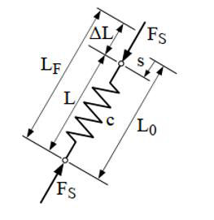

*Figure 6. Coil spring parameters1*

The spring is characterized by its stiffness *k.* The force Fs to create a deflection of the

spring is proportional to its relative displacement of both ends. The elastic element stiffness

k is a function of position and time.

|  |  |  |  |  |  |
| --- | --- | --- | --- | --- | --- |
| 𝑓𝑘 = −𝑘𝑧 = −𝑘(𝑥 − 𝑦) |  |  |  |  | (3.1) |

The common range of elastic elements is in the range of 178 to 203 mm for large cars,

127 to 152 mm for small, compact cars. Since the simulating vehicle is a SYM T880 light

truck, it is safe to consider the stiffness of the spring to be linear, which has a constant

value.

The practical characteristic curve of the damping element is usually obtained from

measurement, by exciting the damper with a sinusoidial displacement signal 𝑢 =

𝑢𝑜𝑠𝑖𝑛2𝜋𝑓𝑡. By varying the frequency 𝑓, different force displacement curves are obtained

and by taking the peak value of each curve, we obtain the characteristics of a damper. The

result gained would look like the figure below:

|  |  |  |
| --- | --- | --- |
| Intructor: Ph.D Tran Dang Long |  | 8 |

STUDY ON AUTOMOTIVE PUSH-ROD SUSPENSION SYSTEM



*Figure 7 Practical characteristic curve of damping element1*

The damping coefficient of damper is measured by the value of mechanical energy

loss in one cycle. It can also be defined as the required force fc to create a motion in the

damper. If fc is proportional to the relative velocity of its ends, it is a *linear damper* with a

constant damping coefficient *c*.

|  |  |  |
| --- | --- | --- |
|  | 𝑓𝑐̇ = −𝑐𝑧̇ = −𝑐(𝑥̇ − 𝑦̇) | (3.2) |

**3.2 Natural frequency and damping ratio:**

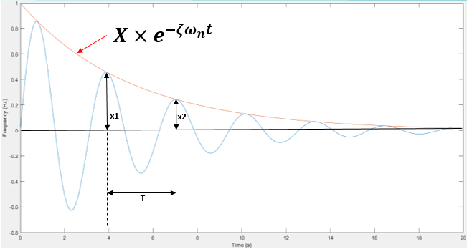

*Figure 8. Underdamped characteristics curve*

|  |  |  |
| --- | --- | --- |
| Intructor: Ph.D Tran Dang Long |  | 9 |

STUDY ON AUTOMOTIVE PUSH-ROD SUSPENSION SYSTEM

|  |  |
| --- | --- |
| **3.2.1** | **Natural frequency:** |

Natural frequency, also known as eigenfrequency or resonant frequency, is the

frequency at which a system tends to oscillate in the absence of any driving or damping

force.

The natural frequency of the vehicle body supported by the main suspension is usually

between 0.2-2 Hz, and the natural frequency of un-sprung mass is between 2 and 20 Hz.

|  |  |  |  |  |
| --- | --- | --- | --- | --- |
| 𝒇𝒏 = | 𝟏  𝑻where T: period of one oscillating cycle |  |  | (3.3) |

The frequency response of mechanical systems is dominated by the natural frequency

of the system. The amplitude of vibration increases when an excitation frequency

approaches one of the natural frequencies of the system. The frequency domain around the

natural frequency is called the resonance zone; the amplitude of the vibration can be

reduced by the effects of the damper.

|  |  |
| --- | --- |
| **3.2.2** | **Damping ratio:** |

The damping ratio is a non-dimension value indicating how a vibration in the system

dissipates over time after being excited.

|  |  |  |  |  |  |  |
| --- | --- | --- | --- | --- | --- | --- |
| 𝜻 = | 𝟏  𝜹)𝟐where 𝜹 = 𝑳𝒏√𝟏+(𝟐𝝅 | 𝒙𝟏  𝒙𝟐 |  |  |  | (3.4) |

The properties of damping ratio can be divided into 3 types: undamped (𝜻 = 𝟎)**,** under-

damped (0 < 𝜻 < 𝟏), critically damped (𝜻 = 𝟏), overdamped (𝜻 > 𝟏**).**

- 𝜁 = 0 (undamped)

The system will remain vibrating with the constant amplitude in corresponding to the

excitation force.

- 0 < 𝜁 < 1 (under-damped)

|  |  |  |
| --- | --- | --- |
| Intructor: Ph.D Tran Dang Long |  | 10 |

STUDY ON AUTOMOTIVE PUSH-ROD SUSPENSION SYSTEM

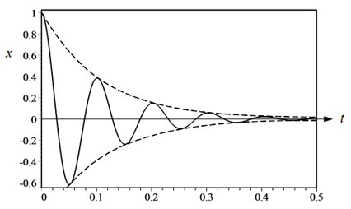

*Figure 9. Sample time response for underdamped system1*

An under-damped system has an oscillatory time response with a decaying amplitude

as shown in the above figure.

- 𝜁 = 1 (critically-damped)

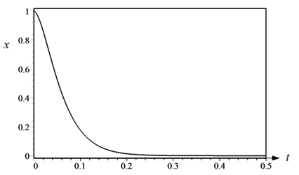

*Figure 10. Sample time response for critically-damped system1*

The damping ratio equals to 1 is the threshold between under-damped and overdamped,

where the vibrating amplitude quickly returns to the original equilibrium and no vibration

occurs.

- 𝜁 > 1 (overdamped)

|  |  |  |
| --- | --- | --- |
| Intructor: Ph.D Tran Dang Long |  | 11 |

STUDY ON AUTOMOTIVE PUSH-ROD SUSPENSION SYSTEM

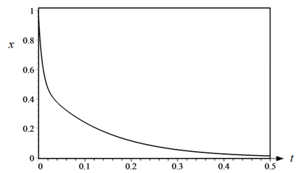

*Figure 11. Sample time response for over-damped syste1*

The over-damped system is the system at which the damping ratio is greater than 1.

Starting from any set of initial conditions, the time response of an overdamped system goes

to zero exponentially, even faster than critically-damped.

This thesis focuses on an underdamped system, which has an oscillatory time response

with a decaying amplitude shown in the above figure. The exponential function 𝑒−𝜉𝜔𝑛𝑡 is

an envelope for the curve of response.

Because with a damping ratio from 0.2 to 0.4, the damped natural frequency is 92 to

98% of the undamped natural frequency. Due to so little difference, the undamped natural

frequency fn is commonly used to characterize the vehicle.

**3.3 Wheel alignment:**

A proper alignment guarantees that all four wheels are in the right alignment for the

vehicle. This is critical for maintaining the safety of the vehicle as well as the tread life of

the tires. Three major parameters govern how each wheel is positioned on the vehicle:

camber, caster and toe. This thesis will only evaluate the change in camber angle, which is

one of the technical characteristics of the Push-rod suspension system.

- Camber angle:

|  |  |  |
| --- | --- | --- |
| Intructor: Ph.D Tran Dang Long |  | 12 |

STUDY ON AUTOMOTIVE PUSH-ROD SUSPENSION SYSTEM

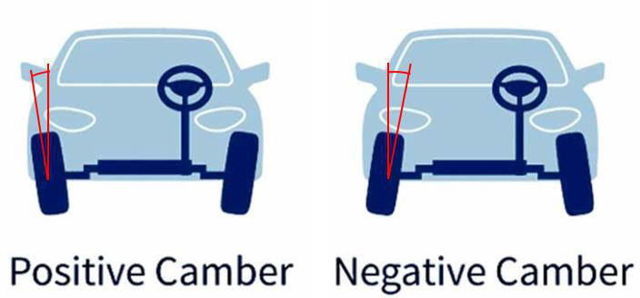

*Figure 12. Positive and Negative camber angle6*

Camber is a design feature that distributes load evenly over the tread. Camber that is

too positive can induce tire wear on one edge and cause the vehicle to pull to the side with

the most positive camber.

Zero camber produces the most consistent tire wear over time, but it may compromise

cornering performance. The optimal camber setting will be determined by different types

of vehicle, driving style and driving circumstances.

Negative camber angle will improve handling during heavy cornering, during straight-

ahead driving, however, it typically lowers the contact surface between the tires and the

road surface.

Positive camber angle helps to reduce the amount of steering effort and it may be ideal

for off-road vehicles such as large agricultural tractors.

- Caster angle:

|  |  |  |
| --- | --- | --- |
| Intructor: Ph.D Tran Dang Long |  | 13 |

STUDY ON AUTOMOTIVE PUSH-ROD SUSPENSION SYSTEM

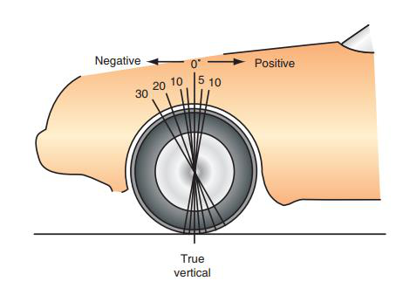

*Figure 13. Positive and negative caster angle9*

Caster is the angle at which a line passing through the tire centerline (the steering axis)

tilts with respect to the tire centerline's actual verticality as seen from the side.

When the centerline of the tire is angled away from its actual vertical centerline,

positive caster occurs. As the centerline of the tire is angled forward when compared to the

centerline when viewed from the side, this is known as negative caster.

When the car is driven straight forward, excessive negative caster causes the steering

to wander. Increased steering effort and a quick steering wheel return after a corner are

symptoms of excessive positive caster. Excessive positive caster also contributes to harsh

ride quality since it directs the caster line.

- Toe:

|  |  |  |
| --- | --- | --- |
| Intructor: Ph.D Tran Dang Long |  | 14 |

STUDY ON AUTOMOTIVE PUSH-ROD SUSPENSION SYSTEM

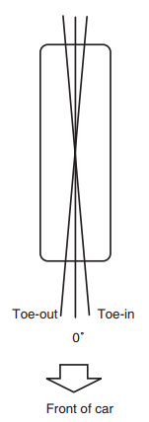

*Figure 14. Toe in and toe out of the wheel9*

When the distance between the front edges of the rear tires is higher than the distance

between the rear edges of the rear tires, a toe-out occurs.

When the gap between the front and rear edges of the rear tires is wider than the gap

between the rear edges, toe-in occurs.

Driving forces on front-wheel-drive cars often cause the rear spindles to go backward.

As a result, these cars often have either zero toe-in or very minor toe-in. Because the wheel

and tire assembly is pushed somewhat laterally while the vehicle is driven, improper rear

wheel toe accelerates the wear on the tire tread. Incorrect rear wheel toe might also cause

steering pulls to one side.

**3.4 Types of road excitation:**

There are 3 types of road excitation: Harmonic profile, transient profile and the random

profile. In this thesis, the harmonic profile is used to simulate the models in order to

|  |  |  |
| --- | --- | --- |
| Intructor: Ph.D Tran Dang Long |  | 15 |

STUDY ON AUTOMOTIVE PUSH-ROD SUSPENSION SYSTEM

evaluate the technical characteristics of the Push-rod suspension system and the

Conventional suspension system.

The harmonic profile is used to analyse the characteristics of the Push-rod suspension

system such as spring stiffness and the relative displacement of suspension system by

examine the gain response of the suspension travel

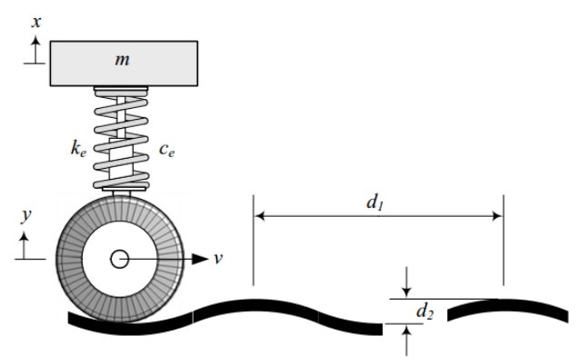

*Figure 15. The harmonic road profile1*

The transient road profile is used to analyse the characteristics of the suspension

system such as damping coefficient, so we can also determine the damping ratio from the

analysis.

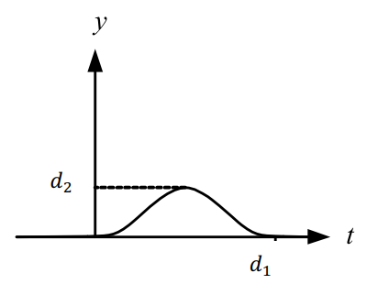

*Figure 16. The transient road profile1*

|  |  |  |
| --- | --- | --- |
| Intructor: Ph.D Tran Dang Long |  | 16 |

STUDY ON AUTOMOTIVE PUSH-ROD SUSPENSION SYSTEM

The last profile is the random road profile, which is used to analyse the ride comfort

of the suspension system by examining the Root-Mean-Square value of the frequency-

weight acceleration of the vehicle body. But in this thesis we will not evaluate the comfort

of the suspension system.

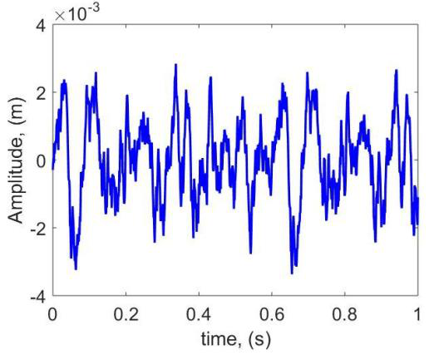

*Figure 17. The random road profile*

|  |  |  |
| --- | --- | --- |
| Intructor: Ph.D Tran Dang Long |  | 17 |

STUDY ON AUTOMOTIVE PUSH-ROD SUSPENSION SYSTEM

**CHAPTER 4: MODEL DESCRIPTION**

**4.1 Method and solutions:**

In order to evaluate the technical characteristics of the Push-rod suspension system, this

thesis will compare it with the Conventional suspension system under the same conditions

of weight, excitation profile, natural frequency and damping ratio.

The method in this thesis is to use SolidWorks to build 3D models of both suspension

systems and import to Matlab/ Multibody environment to build dynamic models and

simulate the models in order to evaluate the technical characteristics of the Push-rod

suspension system.

**4.2 Build 3D model on SolidWorks:**

Build a 3D model of the Push-rod suspension system base on the parameters of the

SYM T880 suspension system on SolidWorks, the table below shows the parameters of the

SYM T880 semi-car suspension system:

|  |  |  |
| --- | --- | --- |
| Intructor: Ph.D Tran Dang Long |  | 18 |

STUDY ON AUTOMOTIVE PUSH-ROD SUSPENSION SYSTEM

|  |  |  |  |
| --- | --- | --- | --- |
| **Parameters** | **Unit** | **Meaning** | **Value** |
| 𝑚𝑠1 | Kg | Sprung weight (1/3 load) | 574 |
| 𝑚𝑠2 | Kg | Sprung weight (2/3 load) | 706 |
| 𝑚𝑠3 | Kg | Sprung weight (full load) | 840 |
| 𝑚𝑢 | Kg | Unsprung weight | 40 |
| 𝑘𝑠 | N/m | Spring stiffness | 28566 |
| 𝑐𝑠 | Ns/m | Damping coefficient | 2090 |

*Table 1. SYM T880 suspension parameters (Source: Vibration analysis of a light truck by 3d dynamic vehicle*

*vibration model by Mr. Truong Hoang Tuan, Dr. Tran Huu Nhan and Mr. Tran Quang Lam.)3*

The weight of the base vehicle is 880 kg, so in the semi-car model, the base sprung

weight will be 440 kg. Similarly, with the load of the vehicle, the maximum load capacity

is 800 kg, so the full load value (including base vehicle weight) will be 840 kg.

After building two 3D models of Push-rod suspension system and Conventional

suspension system (SYM T880), this thesis will need to build a 3D model of the

translational base and fix base to simulate the road profile.

|  |  |
| --- | --- |
|  |  |

*Figure 18. 3D models of Push-rod suspension system and Conventional suspension system*

|  |  |  |
| --- | --- | --- |
| Intructor: Ph.D Tran Dang Long |  | 19 |

STUDY ON AUTOMOTIVE PUSH-ROD SUSPENSION SYSTEM

The figures above are the 3D model of Push-rod suspension system and the

conventional suspension system and the road profile simulation base. The contact surface

between tire and road is redesigned to revolute joint – indicate camber angle and prismatic

joint – indicate tire slip.

This 3D model is also used to solve the kinematic problem that includes the relationship

between the wheel displacement and the suspension travel, the change in camber angle and

the sliding range of the tire.

**4.3 Build dynamic model:**

After building 3D models on SolidWorks, using Matlab/ Multibody to build dynamic

models and simulate the models to evaluate the technical characteristics of the Push-rod

suspension system.

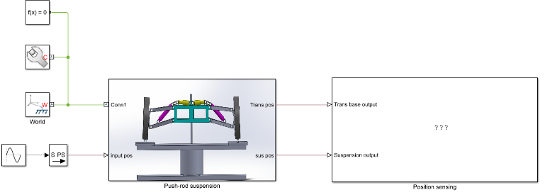

*Figure 19. Simulation model in Matlab/Multibody environment*

The figure above shows the simulation models in the Matlab/ Multibody environment,

it includes blocks that are used to create input parameters to the model and the sensing

blocks that are used to illustrate the result of road profile simulation and translational

position of the vehicle’s body.

|  |  |  |
| --- | --- | --- |
| Intructor: Ph.D Tran Dang Long |  | 20 |

STUDY ON AUTOMOTIVE PUSH-ROD SUSPENSION SYSTEM

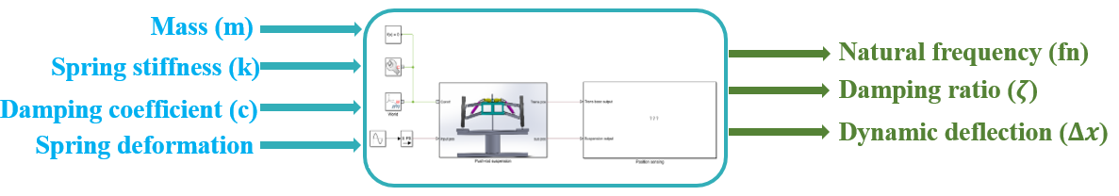

*Figure 20. Simulation input and output parameters*

Using 4 input parameters are mass (m), spring stiffness (k), damping coefficient (c) and

spring deformation to simulate the models and gain the results of natural frequency (fn),

damping ratio (𝜁) and dynamic deflection (∆𝑥).

These simulation models are also used to solve the dynamic problem that include the

determination of spring stiffness and damping coefficient of the Push-rod suspension

system under the same natural frequency and damping ratio with the Conventional

suspension system.

**4.4 Road profile simulation:**

Simulating the road profile with the amplitude is 5 mm in both simulation models of

Push-rod and Conventional suspension system, with the frequency from 0 to 20 Hz.

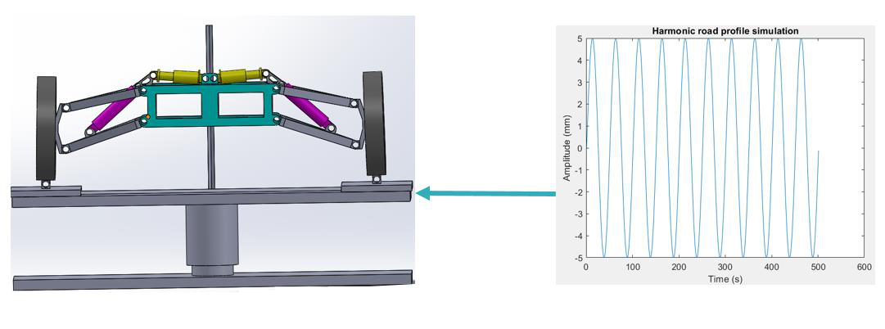

*Figure 21. Harmonic road profile simulation on Matlab/ Multibody*

The wheels will be excited with different harmonic road profiles with the range of

frequency from 0 to 20 Hz under the same amplitude at 5 mm. Using harmonic profile to

simulate the gain response curve of Push-rod and Conventional suspension system to

|  |  |  |
| --- | --- | --- |
| Intructor: Ph.D Tran Dang Long |  | 21 |

STUDY ON AUTOMOTIVE PUSH-ROD SUSPENSION SYSTEM

determine the spring stiffness and damping coefficient under the same natural frequency

and damping ratio.

When the translational base moves up and down with the harmonic profile, the revolute

joint and the prismatic joint are designed to simulate the change in camber angle of the

wheel alignment and the sliding range of the tire’s slip.

**4.5 Calculation flow:**

Using m file to set up the input variables and simulate the model with the frequency

from 0 to 20 Hz, and plot the gain response spectrum of both suspension systems.

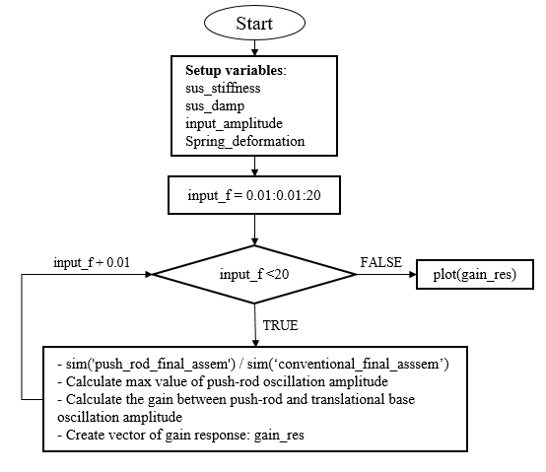

*Figure 22. Calculation flowchart of the simulation models*

|  |  |  |
| --- | --- | --- |
| Intructor: Ph.D Tran Dang Long |  | 22 |

STUDY ON AUTOMOTIVE PUSH-ROD SUSPENSION SYSTEM

The figure above is the calculating flowchart of the simulation model, the calculation

starts with setting up the variables include spring stiffness (sus_stiffness), damping

coefficient (sus_damp), amplitude of road profile (input_amplitude), the spring

deformation (spring_deformation). It will then be taken to solve the simulation model using

the Ordinary Differential Equation solver of the Matlab program (ODE14x).

The results are the gain response spectrum in the frequency domain from 0 to 20 Hz

and the results will be used to evaluate the spring stiffness and damping coefficient of the

Push-rod suspension system under the same natural frequency and damping ratio with the

Conventional suspension system.

**4.6 Conclusion of chapter 4:**

Chapter 4 has presented the idea and method to evaluate the technical characteristics of

the Push-rod suspension system. The results will be discussed in the next chapter later on.

|  |  |  |
| --- | --- | --- |
| Intructor: Ph.D Tran Dang Long |  | 23 |

STUDY ON AUTOMOTIVE PUSH-ROD SUSPENSION SYSTEM

**CHAPTER 5: RESULT AND DISCUSSION**

**5.1 Relationship between wheel displacement and suspension travel:**

This section will present the relationship between wheel displacement and suspension

travel when the suspension travels from minimum point to maximum point with respect to

the change in wheel displacement.

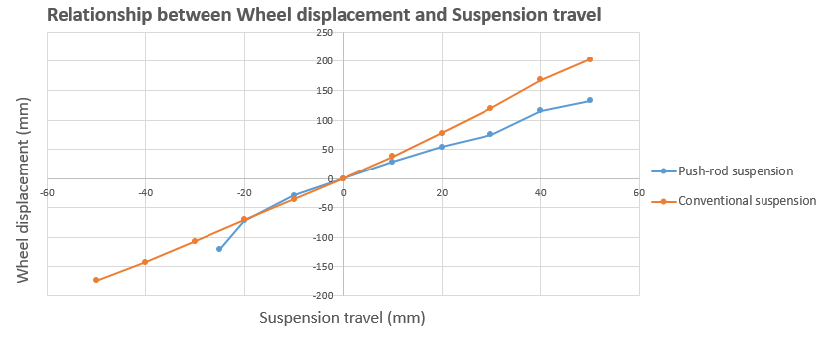

*Figure 23. Relationship between wheel displacement and suspension travel curve*

The figure above illustrates the relationship between wheel displacement and

suspension travel of Push-rod and Conventional suspension systems, with the suspension

travel is the horizontal axsis and the wheel displacement is the vertical axis.

From the figure we can see that the Push-rod suspension system will have a shorter

suspension travel compared to the Conventional suspension system, the suspension travel

of Push-rod suspension system is 25mm shorter than Conventional suspension system. The

maximum and minimum wheel displacement of Push-rod suspension system is 70 mm and

50 mm lower than Conventional suspension system respectively. Therefore, the Push-rod

suspension system will have the lower dynamic deflection that will decrease the body’s

movement.

The relationship between wheel displacement and suspension travel of the

Conventional suspension system is almost a linear curve but the Push-rod is non-linear

|  |  |  |
| --- | --- | --- |
| Intructor: Ph.D Tran Dang Long |  | 24 |

STUDY ON AUTOMOTIVE PUSH-ROD SUSPENSION SYSTEM

curve, the reason for that difference is the Push-rod suspension has more linkage such as

push rod, rocker arm that can affect the relationship between the wheel displacement and

the suspension travel.

**5.2 Change in camber angle and sliding range of tire:**

When the suspension system operates, the wheel alignment will change and the tire will

slip with a sliding range. Both suspension systems use negative camber angle for the benefit

that mentioned in the previous chapter.

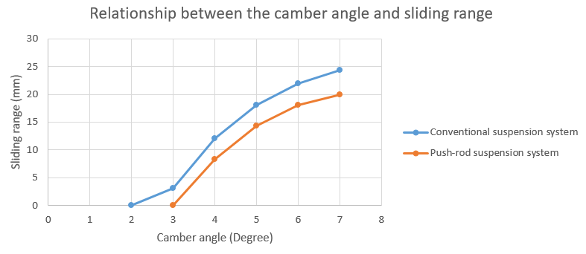

*Figure 24. Relationship between change in camber angle and tire's sliding range curve*

From the figure above, we can see that the camber angle of the Push-rod suspension

will change from 3° to 7° and the Conventional suspension system will change from 2° to

7°, the tire sliding range of Conventional suspension system is almost 4 mm higher than

the Push-rod suspension system, this lead to the tire slip of the Push-rod suspension system

is less than the Conventional suspension system.

**5.3 Gain response spectrum:**

This section will present the gain response spectrum of Push-rod suspension system

and Conventional suspension system in 3 cases: 1/3 load, 2/3 load and full load, the load

value is identical between 2 suspension systems and it is based on SYM T880 parameters.

|  |  |  |
| --- | --- | --- |
| Intructor: Ph.D Tran Dang Long |  | 25 |

STUDY ON AUTOMOTIVE PUSH-ROD SUSPENSION SYSTEM

- **Case 1: 1/3 load**

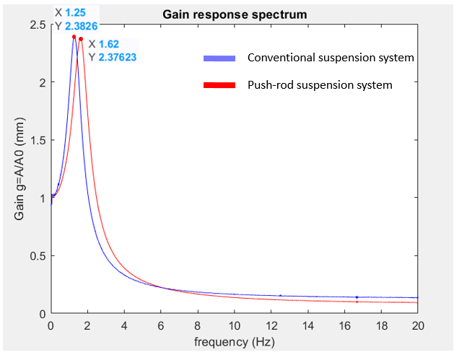

*Figure 25. Gain response spectrum of 1/3 load condition*

Informations:

- 1/3 load: m = 574 kg

- Natural frequency:

o Push-rod suspension system: fn = 1.62 Hz

o Conventional suspension system: fn = 1.25 Hz

- Damping ratio:

o Push-rod and conventional suspension system: 𝜁 = 0.259

From this figure, we can see that at 1/3 load with the natural frequency is in the

allowable range 1.25 Hz for Conventional suspension system and 1.62 Hz for the Push-rod

|  |  |  |
| --- | --- | --- |
| Intructor: Ph.D Tran Dang Long |  | 26 |

STUDY ON AUTOMOTIVE PUSH-ROD SUSPENSION SYSTEM

suspension system, the damping ratio is identical as 0.259, the gain response of both

suspension systems is almost identical (2.38 mm) with the same excited amplitude is 5 mm.

- **Case 2: 2/3 load**

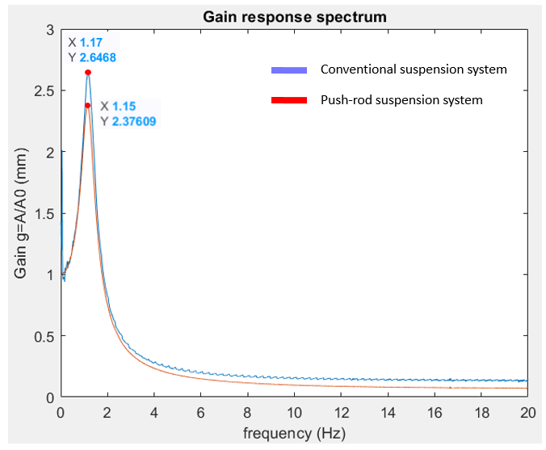

*Figure 26. Gain response spectrum of 2/3 load condition*

Informations:

- 2/3 load: m = 703 kg

- Natural frequency:

o Push-rod suspension system: fn = 1.15 Hz

o Conventional suspension system: fn = 1.17 Hz

- Damping ratio:

|  |  |  |
| --- | --- | --- |
| Intructor: Ph.D Tran Dang Long |  | 27 |

STUDY ON AUTOMOTIVE PUSH-ROD SUSPENSION SYSTEM

o Push-rod and conventional suspension system: 𝜁 = 0.249

From this figure, we can see that at 2/3 load the natural frequency is almost the same at

1.15 Hz for Push-rod suspension system and 1.17 Hz for Conventional suspension system

and the damping ratio is the same at 0.249 but the gain response of the Conventional

suspension system is 0.27 mm higher which mean the oscillation of the vehicle’s body of

Conventional suspension system is higher than the vehicle’s body of Push-rod suspension

system.

- **Case 3: Full load**

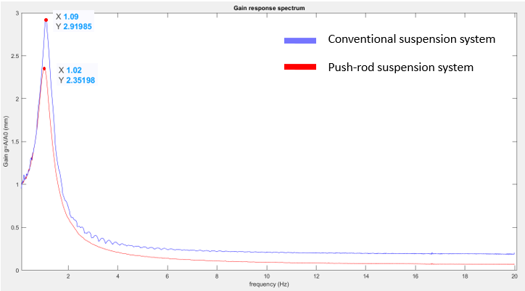

*Figure 27. Gain response spectrum of full load condition*

Informations:

- Full load: m = 840 kg

- Natural frequency:

o Push-rod suspension system: fn = 1.09 Hz

o Conventional suspension system: fn = 1.02 Hz

- Damping ratio:

|  |  |  |
| --- | --- | --- |
| Intructor: Ph.D Tran Dang Long |  | 28 |

STUDY ON AUTOMOTIVE PUSH-ROD SUSPENSION SYSTEM

o Push-rod and conventional suspension sysyem: 𝜁 = 0.274

From this firgure, we can see that at full load the natural frequenct is almost the same

at 1.02 Hz for Push-rod suspension system and 1.09 Hz for Conventional suspension

system and the damping ratio is the same at 0.264 but the gain response of the Conventional

suspension system is 0.56 mm higher which mean the oscillation of the vehicle’s body of

Conventional suspension system is higher than the vehicle’s body of Push-rod suspension

system.

After simulating 3 cases from 1/3 load to full load, we can determine the natural

frequency and damping ratio, spring stiffness and damping coefficient of Push-rod and

Conventional suspension system as the following tables:

|  |  |  |  |  |  |  |  |
| --- | --- | --- | --- | --- | --- | --- | --- |
|  | 1/3 Load | | 2/3 Load | | Full Load  Push-rod Conventional   |  | | --- | |  | | |
| Push-rod Conventional Push-rod | | |  |
|  |  |  |  |  |  |  |
|  |  |  |  |  |  |  |

STUDY ON AUTOMOTIVE PUSH-ROD SUSPENSION SYSTEM

**5.4 Conclusion of chapter 5:**

Chapter 5 has provided the technical characteristics of the Push-rod suspension system

that include the kinematic characteristics which is the relationship between wheel

displacement and suspension travel and the relationship between the camber angle and the

tire sliding range, the dynamic characteristics which is the natural frequency, spring

stiffness and the damping coefficient.

Simulation results show that, with the increase in load from 1/3 to full load, the natural

frequency and damping ratio moderately decrease but still in the reasonable range. The

spring stiffness and damping coefficient of Push-rod suspension system are greater than

|  |  |  |  |
| --- | --- | --- | --- |
| Conventional suspension system. |  |  |  |
| Intructor: Ph.D Tran Dang Long |  |  | 30 |

STUDY ON AUTOMOTIVE PUSH-ROD SUSPENSION SYSTEM

**CHAPTER 6: CONCLUSIONS AND FUTURE WORKS**

**6.1 Thesis conclusion:**

- Compared to the Conventional suspension system, the Push-rod suspension system

has more linkage components which are rocker arms and pushrods to operate the

suspension smoothly, the suspension travel of Push-rod suspension is shorter than

the Conventional suspension system.

- The spring stiffness and damping coefficient of the Push-rod suspension system is

greater than the Conventional suspension system.

- This thesis uses the simulation method on Matlab/ Multibody environment instead

of traditional method is calculus method, the advantage of simulation method

compares to calculus method:

o Simulating the models with a combination of horizontal and vertical

direction.

o Can combine various linkage components in the simulation models.

- After simulation, the Push-rod suspension system will have the following

advantages compare with the Conventional suspension system:

o Hiding the suspension component (spring and damper), the Push-rod

suspension system can modify the pushrods and rocker arm, therefore the

aerodynamics can be optimized.

o With the same excited road profile, the Push-rod suspension system will have

lower oscillating amplitude, so that it will make the vehicle with Push-rod

suspension system more stable than Conventional suspension system.

**6.2 Future works:**

To further develop this thesis, the student can:

- Simulate to evaluate the frequency-weighted acceleration to calculate how intensive

vibrations affect the human body, therefore the simulation can study the ride

comfort of the suspension system.

- Optimize the design of Push rods and the rocker arms.

|  |  |  |
| --- | --- | --- |
| Intructor: Ph.D Tran Dang Long |  | 31 |

STUDY ON AUTOMOTIVE PUSH-ROD SUSPENSION SYSTEM

- Study the relationship between ride comfort and handling of vehicles. To achieve

this, a 3D suspension model is utilized to consider the vehicle rotational motions.

|  |  |  |
| --- | --- | --- |
| Intructor: Ph.D Tran Dang Long |  | 32 |

STUDY ON AUTOMOTIVE PUSH-ROD SUSPENSION SYSTEM

**APPENDIX**

**Push-rod suspension system gain response**

sus_stiffness=36500; %Spring stiffness

sus_damp =1190; %Damping coefficient

input_amplitude = 5; %input amplitude

spring_deformation = -20; %1/3 load

spring_deformation = -26; %1/2 load

spring_deformation = -23; %Full load

gain_res=[,]

f0=0.01;

for input_f=f0:f0:20 %input hz

sim('push_rod_final_assem_test4_2021') %1/3 load

sim('push_rod_final_assem2_2/3'’); %1/2 load

sim('push_rod_final_assem2_full3'); %Full load

A=(max(unspung_pos.signals.values(350:501))-

min(unspung_pos.signals.values(350:501)))/2;

A0=(max(base_pos.signals.values(350:501))- min(base_pos.signals.values(350:501)))/2;

g=A/A0

gain_res=[gain_res; input_f g];

disp(input_f);

save('push_rod_final_assem_test4_2021'); %1/3 load

%save('push_rod_final_assem2_2/3'); %1/2 load

%save('push_rod_final_assem2_full3');

|  |  |  |
| --- | --- | --- |
| Intructor: Ph.D Tran Dang Long |  | 33 |

STUDY ON AUTOMOTIVE PUSH-ROD SUSPENSION SYSTEM

end

plot(gain_res(:,1),gain_res(:,2),'r');

title('Gain response spectrum');

xlabel('frequency (Hz)');

ylabel('Gain g=A/A0 (mm)');

|  |  |  |
| --- | --- | --- |
| Intructor: Ph.D Tran Dang Long |  | 34 |

STUDY ON AUTOMOTIVE PUSH-ROD SUSPENSION SYSTEM

**Conventional suspension system gain response**

sus_stiffness=14283; %Spring stiffness

sus_damp = 1045; %Damping coefficient

input_amplitude = 5; %input amplitude

spring_deformation = -36; %spring deformation

spring_deformation = -30;

gain_res=[,]

f0=0.01;

for input_f=f0:f0:20 %input hz

sim('conventional_final_assem_test7_2021');

sim('conventional_final_assem_test_2/3');

sim('conventional_final_assem_test_full');

A=(max(unspung_pos.signals.values(350:501))-

min(unspung_pos.signals.values(350:501)))/2;

A0=(max(base_pos.signals.values(350:501))- min(base_pos.signals.values(350:501)))/2;

g=A/A0

gain_res=[gain_res; input_f g];

disp(input_f);

save('conventional_final_assem_test7_2021');

save('conventional_final_assem_test_2/3');

end

plot(gain_res(:,1),gain_res(:,2));

title('Gain response spectrum');

|  |  |  |
| --- | --- | --- |
| Intructor: Ph.D Tran Dang Long |  | 35 |

STUDY ON AUTOMOTIVE PUSH-ROD SUSPENSION SYSTEM

xlabel('frequency (Hz)');

ylabel('Gain g=A/A0 (mm)');

|  |  |  |
| --- | --- | --- |
| Intructor: Ph.D Tran Dang Long |  | 36 |

STUDY ON AUTOMOTIVE PUSH-ROD SUSPENSION SYSTEM

**Push-rod suspension system damping ratio determination**

sus_stiffness=30000; %Spring stiffness

sus_damp = 1190; %Damping coefficient 1045

input_amplitude = 5; %input amplitude

%spring_deformation = -20; %1/3 load

%spring_deformation = -26; %1/2 load

spring_deformation = -32; %Full load

input_f=0;

%sim('push_rod_final_assem_test4_2021'); %1/3 load

%sim('push_rod_final_assem2_2/3'); %1/2 load

sim('push_rod_final_assem2_full3'); %full load

A=(max(unspung_pos.signals.values(350:501))-

min(unspung_pos.signals.values(350:501)))/2;

A0=(max(base_pos.signals.values(350:501))- min(base_pos.signals.values(350:501)))/2;

g=A/A0;

plot(unspung_pos.signals.values,'r');

title('Harmonic road profile simulation');

xlabel('Time (s)');

ylabel('Amplitude (mm)');

|  |  |  |
| --- | --- | --- |
| Intructor: Ph.D Tran Dang Long |  | 37 |

STUDY ON AUTOMOTIVE PUSH-ROD SUSPENSION SYSTEM

**Conventional suspension system damping ratio determination**

sus_stiffness=28566; %Spring stiffness

sus_damp = 2090; %Damping coefficient 1045

input_amplitude = 5; %input amplitude

%spring_deformation = -30; %deformation

spring_deformation = 500;

input_f=0;

%sim('conventional_final_assem_test7_2021'); %1/3 load

%sim('conventional_final_assem_test_2/3'); %1/2 load

%sim('conventional_final_assem_test_full'); %full load

A=(max(unspung_pos.signals.values(350:501))-

min(unspung_pos.signals.values(350:501)))/2;

A0=(max(base_pos.signals.values(350:501))- min(base_pos.signals.values(350:501)))/2;

g=A/A0;

plot(unspung_pos.signals.values);

title('Gain response spectrum');

xlabel('frequency (Hz)');

ylabel('Gain g=A/A0 (mm)');

%gain_res=[gain_res; input_f g];

|  |  |  |  |
| --- | --- | --- | --- |
| %plot(gain_res(:,1),gain_res(:,2)); |  |  |  |
| Intructor: Ph.D Tran Dang Long |  |  | 38 |

STUDY ON AUTOMOTIVE PUSH-ROD SUSPENSION SYSTEM

**REFERENCES**

[1] Georg Rill (2012), *Road Vehicle Dynamics: Fundamentals and Modeling*, CRC

Press.

[2] MathWorks, *Student competition programs,* MathWorks Support for Student

Competitions

https://www.mathworks.com/academia/student-competitions.html

[3] Truong Hoang Tuan, Tran Huu Nhan, Tran Quang Lam (2015). *Vibration analysis of*

*a light truck by 3d dynamic vehicle vibration model*, Science and Technology

Development Journal.

[4] Thomas D. Gillespie (1992), *Fundamentals of Vehicle Dynamics*, Society of

Automotive Engineers.

|  |  |
| --- | --- |
| [5] | Figure of Push-rod suspension system at |

https://suspensionsguy.wordpress.com/2020/08/02/example-post-3/

|  |  |
| --- | --- |
| [6] | Figure of Positive and Negative camber angle at https://cartreatments.com/what-is- |

camber/

|  |  |
| --- | --- |
| [7] | Bayer, Andrew (May 2009). Adjustable Pushrod Suspension Design (PDF) (Thesis). |

University of Cincinnati.

|  |  |
| --- | --- |
| [8] | Karthik.S, Krupa R, Smruti Rekha Sen. (2016). "Design and Analysis of a Pushrod |

Suspension System for a Formula Racing Car" (PDF). Technical Research

Organisation India.

|  |  |
| --- | --- |
| [9] | Don knowles, Dave Garza, Sandy Clark, David Boelio. (2019). "Today’s |

Technician™: Automotive Suspension & Steering Systems, 5th Edition" (PDF).

|  |  |  |
| --- | --- | --- |
| Intructor: Ph.D Tran Dang Long |  | 39 |